Name:_________________________________________________ Date:________________ Period: _______

Circuits – Quiz 2A (15 Points) HONORS Mr. Werman
Multiple Choice I: Write the letter of the best answer in the space provided. (1 point each)

______1) Which of the following configurations will light the bulb?
a) 1, 3, 4, and 5 c) 2, 3, and 5
b) 1, 3, and 4 d) All Five







1 2 3 4 5






______2) A toaster (10 Ω), coffee maker (12 Ω), microwave (40 Ω), and blender (50 Ω) are plugged into a home power strip receiving 120 V. Which appliance will draw the most power when running?
a) toaster c) microwave
b) coffee maker d) blender

______3) Several resistors of varying values are wired in series. What is true about this circuit?
a) The sum of the currents through each resistor will equal the total circuit current.
b) The total circuit current will be the same as the current through any one resistor.
c) The voltage across any resistor is the same as the voltage of the power supply.
d) The current will be slowest through the largest resistor and fastest through the lowest resistor.

______4) Several resistors of varying values are wired in parallel. What is true about this circuit?
a) The current through each resistor will equal the total circuit current.
b) The voltage across each resistor will be the same.
c) The addition of each resistor to the circuit increases the overall resistance of the circuit.
d) The voltages across each resistor add up to the total voltage from the power supply.

______5) Three identical bulbs are wired as shown in Figure A. Which statement below is TRUE?
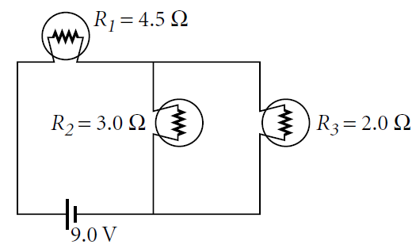



a) Unscrewing Bulb 3 would NOT affect the brightness of
Bulbs 1 and 2.
Bulb 1
Bulb 2
Bulb 3
b) The current passing through Bulb 1 is the same as the
the current through Bulb 2.
c) Bulb 1 and Bulb 2 will drop the same Voltage
d) Bulb 1 will be brighter that Bulb 3

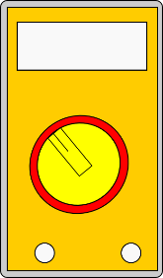
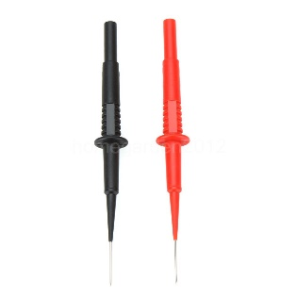
6) The following items are on the table in the physics room. Draw wires to properly connect a circuit to light both bulbs in series. Include the ammeter in the circuit and connect the leads of the Voltmeter to the circuit such that it reads 1.5 V. Write the value that would be read on the ammeter in this circuit. Include units. (5 points)
1.5 V
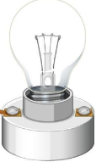
10 Ω

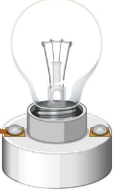
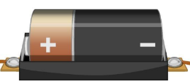
10 Ω
3.0 V

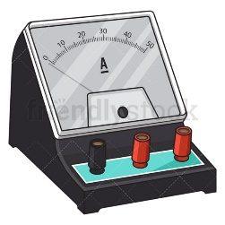

__________________ (Ammeter Reading)

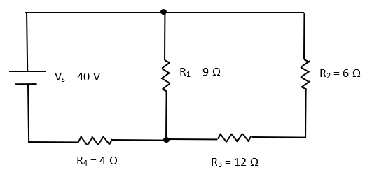
7) What is the total current leaving the battery? (5 Points)

Name:_________________________________________________ Date:________________ Period: _______

Circuits – Quiz 2B (15 Points) HONORS Mr. Werman
Multiple Choice I: Write the letter of the best answer in the space provided. (1 point each)

______1) Which of the following configurations will light the bulb?
a) 1, 3, 4, and 5 c) 2, 3, and 5
b) 1, 3, and 4 d) All Five







1 2 3 4 5






______2) A toaster (10 Ω), coffee maker (12 Ω), microwave (40 Ω), and blender (50 Ω) are plugged into a home power strip receiving 120 V. Which appliance will draw the most power when running?
a) toaster c) microwave
b) coffee maker d) blender

______3) Several resistors of varying values are wired in series. What is true about this circuit?
a) The sum of the currents through each resistor will equal the total circuit current.
b) The total circuit current will be the same as the current through any one resistor.
c) The voltage across any resistor is the same as the voltage of the power supply.
d) The current will be slowest through the largest resistor and fastest through the lowest resistor.

______4) Several resistors of varying values are wired in parallel. What is true about this circuit?
a) The current through each resistor will equal the total circuit current.
b) The voltage across each resistor will be the same.
c) The addition of each resistor to the circuit increases the overall resistance of the circuit.
d) The voltages across each resistor add up to the total voltage from the power supply.

______5) Three identical bulbs are wired as shown in Figure A. Which statement below is TRUE?




a) Unscrewing Bulb 3 would NOT affect the brightness of
Bulbs 1 and 2.
Bulb 1
Bulb 2
Bulb 3
b) The current passing through Bulb 1 is the same as the
the current through Bulb 2.
c) Bulb 1 and Bulb 2 will drop the same Voltage
d) Bulb 1 will be brighter that Bulb 3



6) The following items are on the table in the physics room. Draw wires to properly connect a circuit to light both bulbs in parallel. Include the ammeter in the circuit to read the total current and connect the leads of the Voltmeter to the circuit such that it reads 3.0 V. Write the value that would be read on the ammeter in this circuit. Include units. (5 points)
3.0 V



10 Ω


10 Ω


3.0 V

__________________ (Ammeter Reading)


7) What is the total current leaving the battery? (5 Points)

